Taking attendance in Zoom

Be sure to set up your meeting with:
Only authenticated users can join" box, and then selecting the "UNC Zoom SSO" option below that. This will ensure that everyone joining your meeting is A. UNC-affiliated, and B. using their SSO licensed Zoom account.

After the meeting:

Sign into zoom.unc.edu and choose reports.
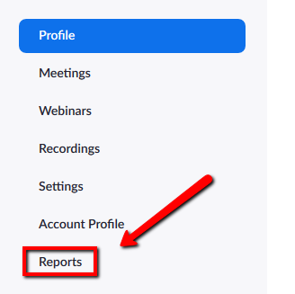
Click Usage.
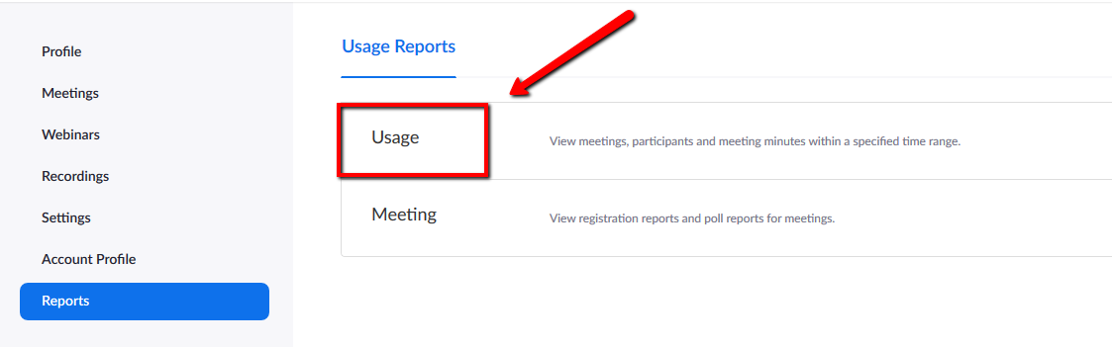
Click the blue, hyperlinked number under the Participants column.
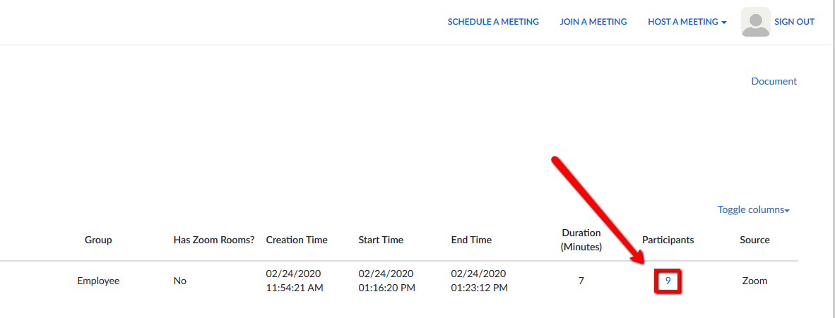
You will now see your meeting's attendance report. If you wish, you can press the blue Export button to save this information to your device.